Given a complete directed graph with $n$ vertices not containing the below subgraph, find the sum of distances between all ordered pairs of vertices. ( $614n$ if cannot go)

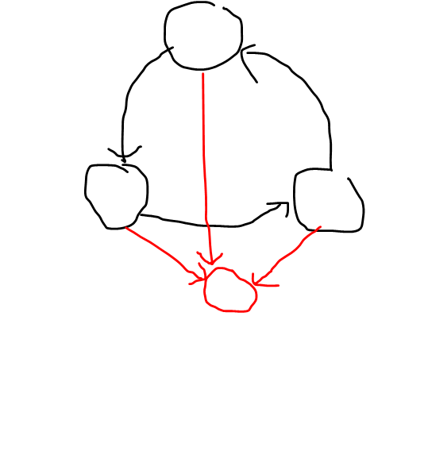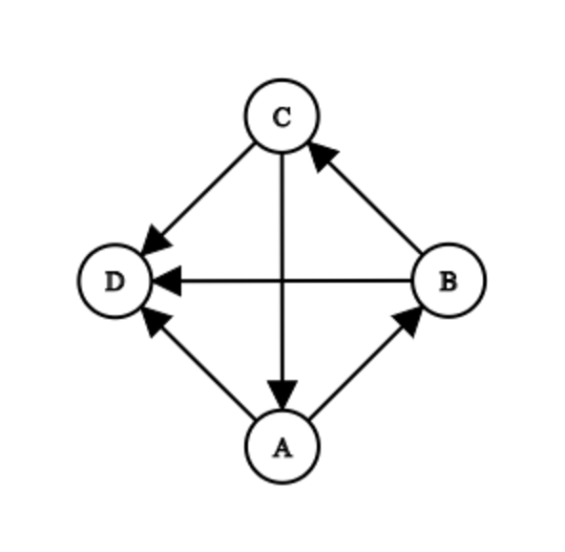

Observation 1:

The graph can be thought of as a cycle of length 3 all pointing to another vertex.

Observation 2:

Vertices with zero in-degree can be removed as their contribution can be calculated easily (bfs)

Define $in\left(x\right)$ to be the set of nodes $u$ such that $u→x$ exists.

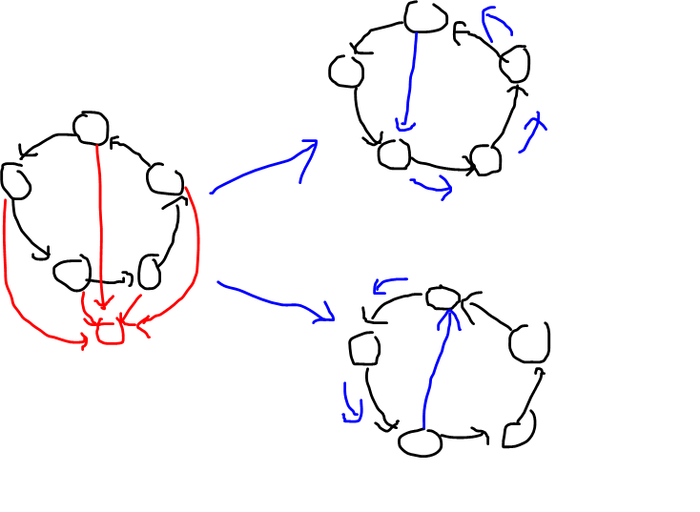

Observation 3:

$in\left(x\right)∪x$ does not contain cycles.

Explanation:

If there is a cycle bigger than 3, you can divide it into a smaller cycle no matter which direction an edge is (edges must all exist as it is a complete graph), and if you continue there will always be a cycle with size 3, which is the subgraph the graph don’t have, so it is impossible to have a cycle. (cycle can’t contain x either as both are pointing to x)

Let $X$ be a node with maximum in-degree. Let $P$ be $in\left(X\right)∪X$ and $Q$ be $vertices not in P$.

Observation 4: For all pairs $U∈Q, V∈P$, there is at least one pair such that $U→V$ exists.

Explanation: Since $P$ is acyclic, it can be topological sorted. This means there must be a vertex with no in-degree (within $P$). However, we removed all vertex with zero in-degree in the whole graph, so there must be some edge pointing to it that comes from $Q$.

Let $P'$ be $in\left(V\right)∩Q$ and $Q'$ be $Q∖P'$.

Observation 5: $P'$ does not contain cycles.

Explanation: same as observation 3

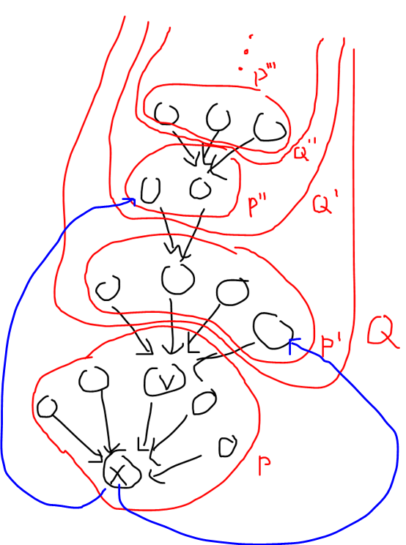Observation 6: $Q$ does not contain cycles.

Explanation: You can repeat the above process until $Q$ is broken up into a series of acyclic components. (Very cool!) Also cycles cannot form between components in $Q$ as it is a bamboo graph. Edges from $X$ to vertices in $Q$ can form cycles, but it doesn’t matter as the cycles are not completely in $Q$. (obviously $X$ will not connect to other vertices in $P$)

Now we proved that the graph can be separated into 2 acyclic sets ( $P$ and $Q$), we can topological sort them and do some stuff.

Label vertices in $P$ such that if $i<j$, $P_{i}→P_{j}$ exists. (same for $Q$)

Observation 7: $dist\left(P_{i},Q_{j}\right)+dist\left(Q_{j},P_{i}\right)=3$

if $dist\left(Q_{j}, P_{i}\right)=1$, you can go from $P_{i}$ to $X$ to $Q_{j}$.

$X$ to $Q_{j}$ must exist as if it’s the opposite $Q_{j}$ will be in $P$

if $dist\left(P_{i}, Q_{j}\right)=1$,